1. As per below please look for similar suitable images in Google for Client Log In and Admin Log In Image along with logo.

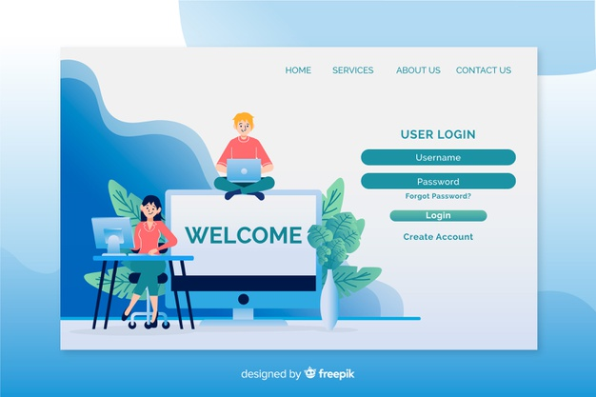

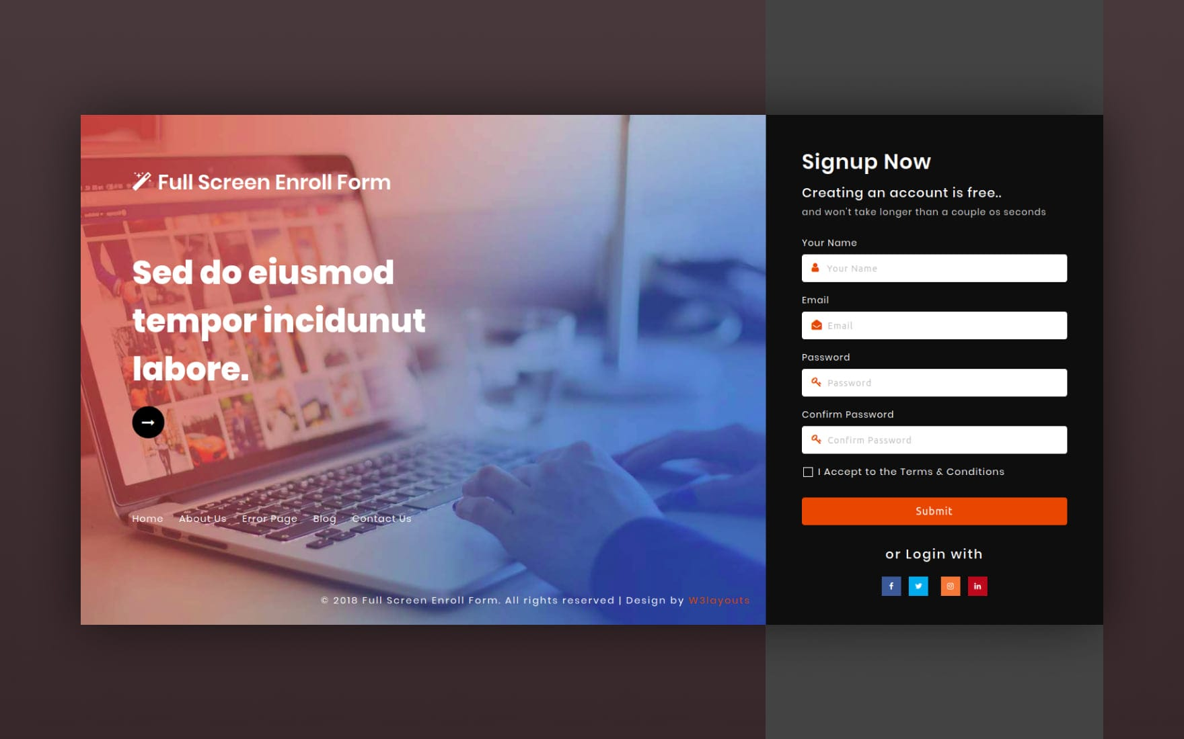

1. First report generates page Space option in LOCATION Box. – space in location – masterchecker.php for Location input
2. Space in not coming in MARITAL STATUS Box. – need to change to dropdown - masterchecker.php
   1. Married
   2. Single
3. Client Master Tracker there should be filter option for every case for select & delete if required. And in every individual client we want the filter option for every candidate wise. – option for bulk deleting by checking n check boxes, need to add seriel no., last added should come to top.
4. Invoice generation page Kindly give option to select each case wise along with filter option so that we can bill based on we select the case list. – PDF filtering is not working properly, filtering should be based on the reported date(date in bottom of the entry page), also need to add reported date in the completed list, ‘Status’ needed to be changed to ‘Over all status’.
5. **Invoice 2nd Page Ref id** rename **to Ref ID, Additional Fee** Rename to **Add Fee**
6. We have to set up the Invoice Annexure page Autofit properly.
7. Please change the invoice calculation count as only Final report generated & not the overall received in month. - Accounts and finance – take data for overall status = completed
   1. The dropdown for month should be reported month.
8. Left bar menu Accounts & Finance rename to Generate Invoice.
9. After invoice page setup there should be all calculation working properly. I mean recheck. –

Generate Invoice

* 1. Check alignment
  2. Need to change the signature image
  3. Line below Annexure in second page should be removed

1. **Report Sent Date** Rename to **Report Date**, Date format should be DD/MM/YY
2. **Client Master Tracker** In **View Track Status** page we have to add **Final Report Date** before Status. - Need to add reported date in the list after over all status.
3. Kindly rename **Client Reference ID**, as **Client Code** in all the place where all applicable.
4. In Excel format is not showing correctly, please download and check so that you will aware.
   1. Excel tracker – excel file
      1. 3 way filtering
         1. Company+month+year
         2. Month+year
      2. Over status should be place rightmost
      3. Add column No of days taken, Report status before overall status
      4. After company name, add Employee code, GQG Reference ID
5. Month wise Excel data we requested few changes please do keep the Overall Status in corner of the Row.
6. Bug: upper case for ‘Remarks’ input in Client master tracker(masterchecker.php) – need to check and verify.
7. While entering the candidate details in application there should be few mandatory Entries those, we have to highlighted like showing STAR or pop up to enter data.
   1. Month-year
   2. Client company location
   3. GQG Reference ID
   4. Candidate full name
   5. Contact number
   6. DOB
   7. Gender
   8. Nationality
   9. Case initiated date
   10. All selected services
   11. Over all status(at the bottom)
   12. Report status
   13. Report type
   14. Final verification status
   15. Case closure date - TAT
8. **‘Time stamp applications’ in email subject line to ‘TAT Exceeded Applications’.**
9. **Add an input after ‘Add attachments’ (Use only for Insufficiency Document Attachment – Browse file) in Client login credentials -> click go->login->** **customer-index.php.**
   1. **Allowed formats – All(PDF, jpg, png, word, excel etc)**
   2. **Add delete option in the table**
10. **Drug Test - Drug Name we should replace, heading “Drug Test” (12panel) sub categories 1 Panel to 18 Panel, please refer Excel in detail.**

**Data Entry page In Candidate Application Drug Test Component Please Give Filter option with all Drug Panel details to visible so that we will tick and chose how many Panel required 1 to 18 Panel.**

|  |  |  |
| --- | --- | --- |
| **5 Panel** | **6 Panel** | **7 Panel** |
| Marijuana | Benzodiazepines / Oxazepam | Benzodiazepines / Oxazepam |
| Cocaine / Benzoylecgonine | Barbiturates /Secobarbital | Barbiturates /Secobarbital |
| Phencyclidine | Opiates / Morphine | Opiates / Morphine |
| Amphetamines | Cocaine / Benzoylecgonine | Cocaine / Benzoylecgonine |
| Opiates / Morphine | Amphetamines | Amphetamines |
|  | Marijuana | Marijuana |
|  |  | Methadone |

|  |  |  |
| --- | --- | --- |
| **8 Panel** | **9 Panel** | **10 Panel** |
| Benzodiazepines / Oxazepam | Amphetamines | Opiates / Morphine |
| Barbiturates /Secobarbital | Barbiturates /Secobarbital | Oxycodone |
| Opiates / Morphine | Benzodiazepines / Oxazepam | Propoxyphene |
| Cocaine / Benzoylecgonine | Cocaine / Benzoylecgonine | Benzodiazepines / Oxazepam |
| Amphetamines | Methamphetamine | Marijuana |
| Marijuana | Opiates / Morphine | Barbiturates /Secobarbital |
| Methadone | Marijuana | Cocaine / Benzoylecgonine |
| Phencyclidine | Methadone | Amphetamines |
|  | Phencyclidine | Glucuronide |
|  |  | Tramadol |

|  |  |
| --- | --- |
| **11 Panel** | **12 Panel** |
| Opiates / Morphine | Amphetamines |
| Oxycodone | Glucuronide |
| Propoxyphene | Cocaine / Benzoylecgonine |
| Benzodiazepines / Oxazepam | Marijuana |
| Marijuana | Opiates / Morphine |
| Barbiturates /Secobarbital | Barbiturates /Secobarbital |
| Cocaine / Benzoylecgonine | Methylenediioxy-MET |
| Amphetamines | Benzodiazepines / Oxazepam |
| Glucuronide | Methamphetamine |
| Tramadol | Oxycodone |
| Phencyclidine | Phencyclidine |
|  | Methadone |

1. Client Login – In Drop Box Give the All scope of services tic boxes to select the services.
   1. **Add a left panel and copy the Service name inputs with tick box same as in the new client registration menu.**
2. Client Login –
   1. Change menu name ‘drop box’ in client logged in portal to client drop box
   2. One additional menu in client logged in portal – ‘Candidate drop box’ below drop box
      1. Add a left panel and copy the Service name inputs with tick box same as in the new client registration menu.
      2. Candidate Name, Mobile number, Email ID, Location, Employer name, one time link should go to browse & upload documents.-
      3. New page(view) – copy the content from drop box
      4. In form, add Mobile number , email id, work location after employee name.
      5. Remove attach documents and remarks.
      6. Rename ‘Submit’ to ‘Submit to send link to candidate’.
      7. When clicked on this button a link will be sent to candidate email.
      8. When candidate click on that link, a page should open with a form(download form myself(BGV form from client home page - bottom))
         1. Up to marital status all inputs are mandatory
         2. For educational details, there should be one option for add more edu qualifications.
         3. Upload doc(certificate) – mandatory
         4. Up to 4 employer details.
         5. All employer details mandatory
         6. ID details: add drop down(type of id proof)
         7. ID No
         8. Upload ID proof
         9. Declaration authorization
         10. Submit
         11. Send form details to email as pdf

**NB:** Client will fill Candidate Name, Mobile number, Email ID, Location, Employer name(all are mandtory) by keeping others empty. Then an email will go to the candidate email id with a link attached for filling the other inputs.

1. Acknowledgement email we require option to add the GQ reference Number. – Add a column GQG Ref ID with input option, add a column, candidate name.
2. Case Exceeded cases should also marked [bgvcst@goldquestglobal.in](mailto:bgvcst@goldquestglobal.in) . – add this email to addaddress.
3. Delete option in Add GoldQuest Employee.
4. Select dropdowns are not autopopulating with updated data in Client master tracker-> masterchecker.php, For input Annexure all file formats should be allowed. .
5. Final report in client master tracker should be attached with all the files uploaded from masterchecker.php regardless of format(what ever the format, it should attach with the final report)
6. Change Cases to Case Status and options to Pending reports and Completed Report in client master tracker..
7. Add multiple inputs for Email ids
8. Change Email to To Email (client), then CC Email (Client), then CC Email (GQG)
9. Remarks in report – Need to remove starting caps from the words(report generates from masterchecker.php)
10. Need to change the domain
11. Client master tracker -> select from comlpeted list ->: Final report should reflect all the changes made.
12. Client dropbox – after submitting all the data should go to client email [bgvcst@goldquestglobal.in](mailto:bgvcst@goldquestglobal.in) , all filled data along with service name should go to the email id.
13. customer-index.php – In education check for Post graduation and graduation a dropdown should come for all master degrees and ugs corresponding the selected(post graduation/ Graduation).
14. Masterchecker.php – Basic repeating inputs(Candidate ref id, candidate full name, father name etc) should autofill from the first entry where ever its repeating.
15. Candidate name should rename to Candidate Full Name in all the places.
16. Cron job for sending remainder emails for selected services if its in INSUFF – CC: [bgvcst@goldquestglobal.in](mailto:bgvcst@goldquestglobal.in) – Server side.
17. customer-index.php - Selected Services: should beautify the table
18. Email sending not working from my local.
19. Masterchecker.php – each section should be separated properly.
20. masterchecker.php – Drug panel: Each category should only contain the drugs which belongs to the panel
21. Keep unique fornt format, size etc every where in the system.

**After all the changes we want the same to transfer to Godaddy account and set up properly without any challenges to use.**

**While individual client login there should not be any security restrictions to login and use**

**Looking forward your support to give us the VTS in proper handover without any challenges to use, Service support for a week to monitor and keep you posted if any challenges.**

Excel Data – We required client wise & we want the Filter option to download the client wise candidate details & complete address to assign a vendor.

Add employee – Only numeric able to type, letters unable to type.

In Report correction option should be required and not to delete and start first.

Move left, right, top and down option in where all its applicable.

Rename correction as per Final Report table or as per data entry application.

Should be able upload and download any files irrespective in dropbox.

Complete invoice in landscape format. If required will share the format.

**03/11/2021**

**Admin->Create GoldQuest login->Add employee**

**Employee id sould countain ‘GQ-[0-9]{4}’**